# Include variable value in bookmark

## Step 1:

Create a variable in Qliksense application using variable editor

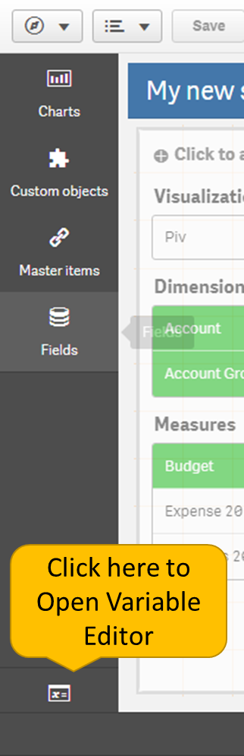 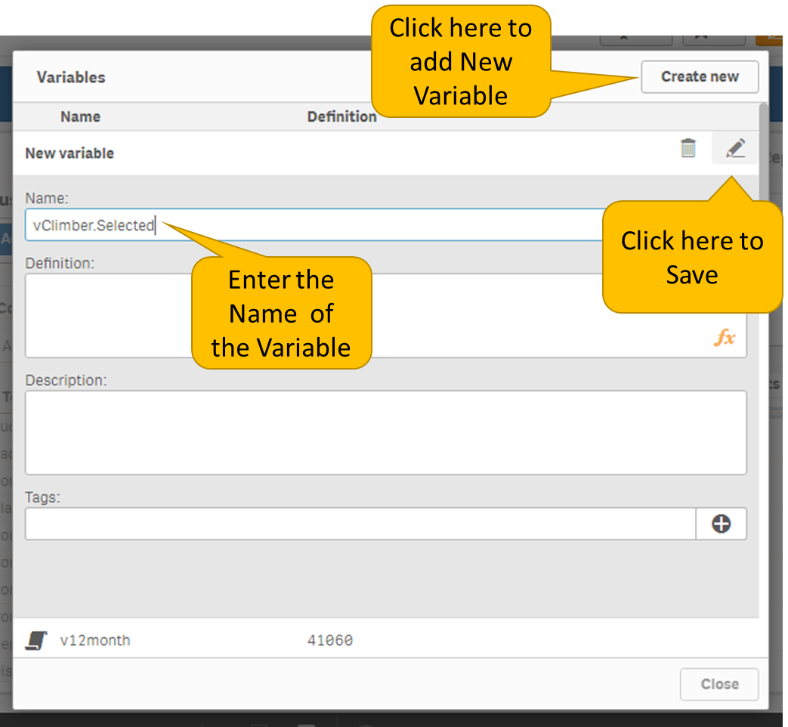

## Step 2:

Open the Qliksense dev hub

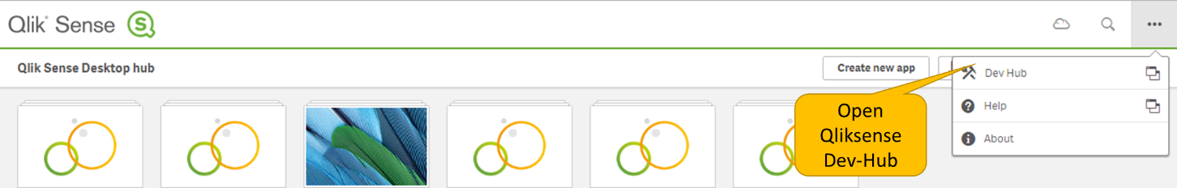

## Step 3:

Select the Engine API Explorer

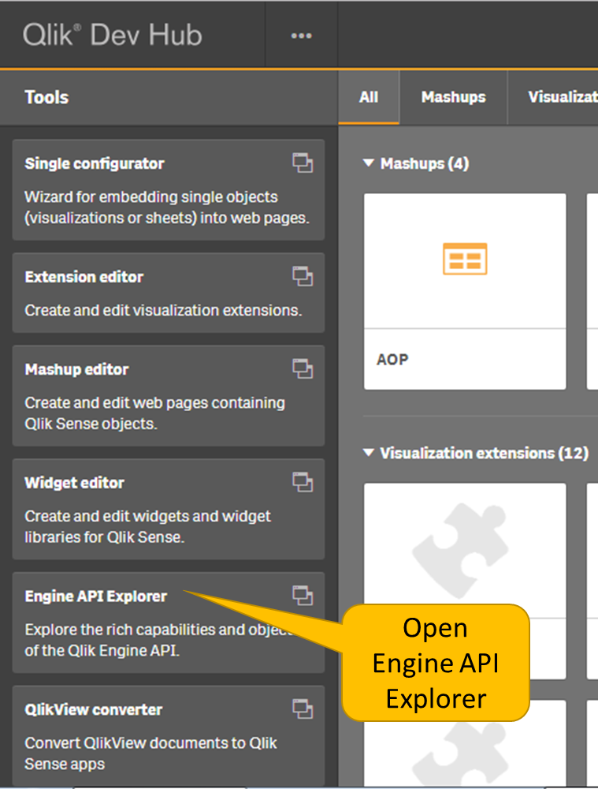

## Step 4:

Select Connect to Engine and choose the application from the drop down

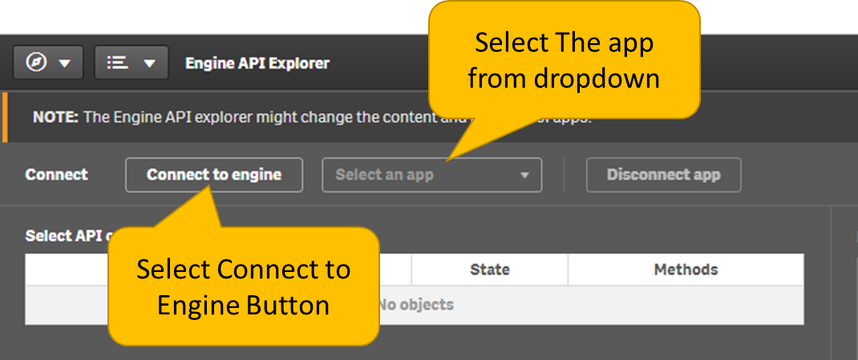

## Step 5:

Once selected an extra row will be added to the below Object List. From that choose the **GetVariableByName** Method

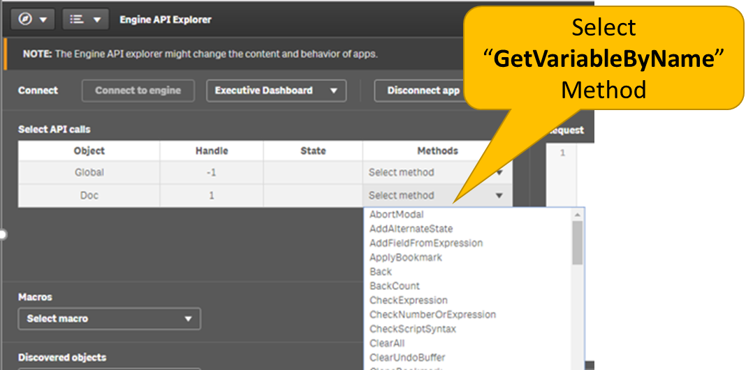

## Step 6:

Enter the variable name and execute the method

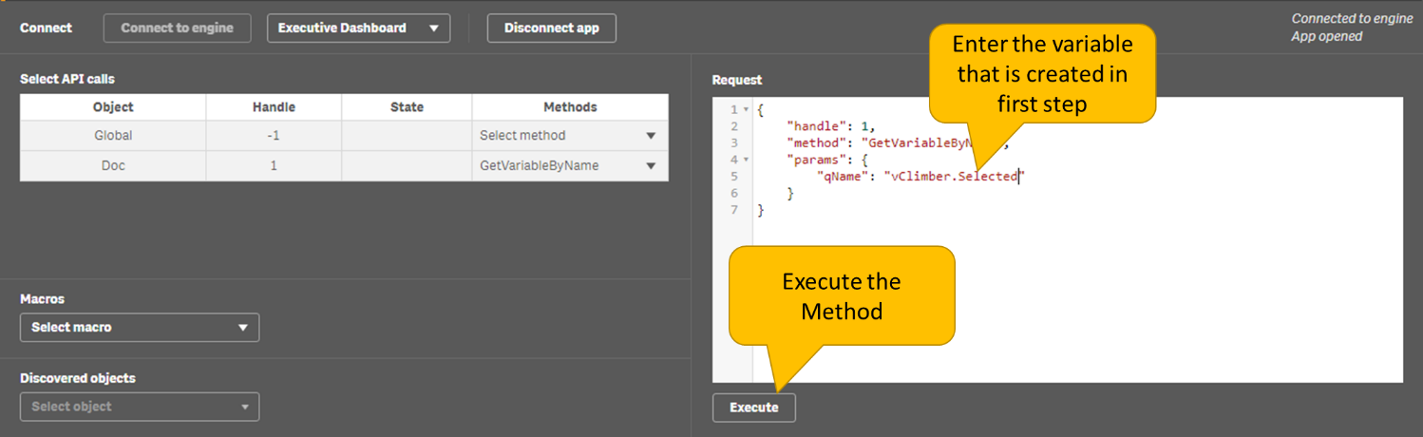

## Step 7:

Once executed. The result will be displayed in the bottom screen. Expand the Execution log and copy the qGenericId

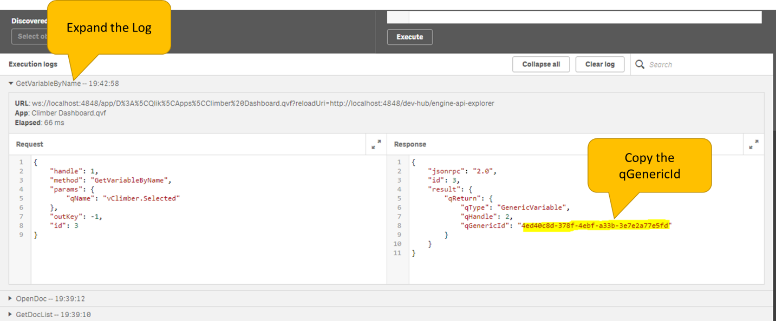

## Step 8:

Select GetVariableById from the method and enter the copied id and execute the method

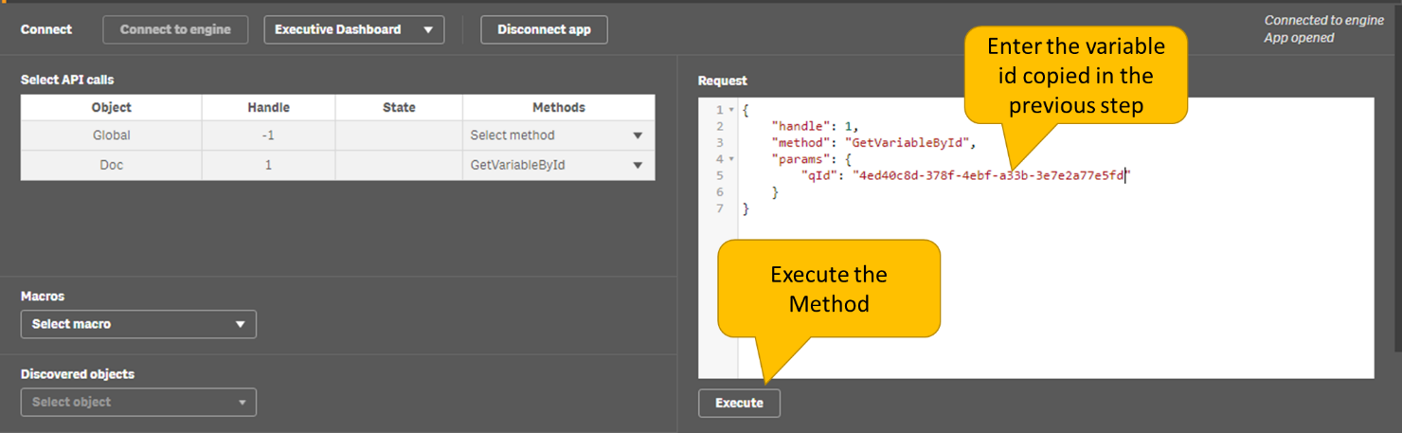

## Step 9:

Once executed an extra row will be added for variable. Select the set property method from methods drop down. Enter the Id, Variable Name and Include Bookmark property as show in below screenshot.

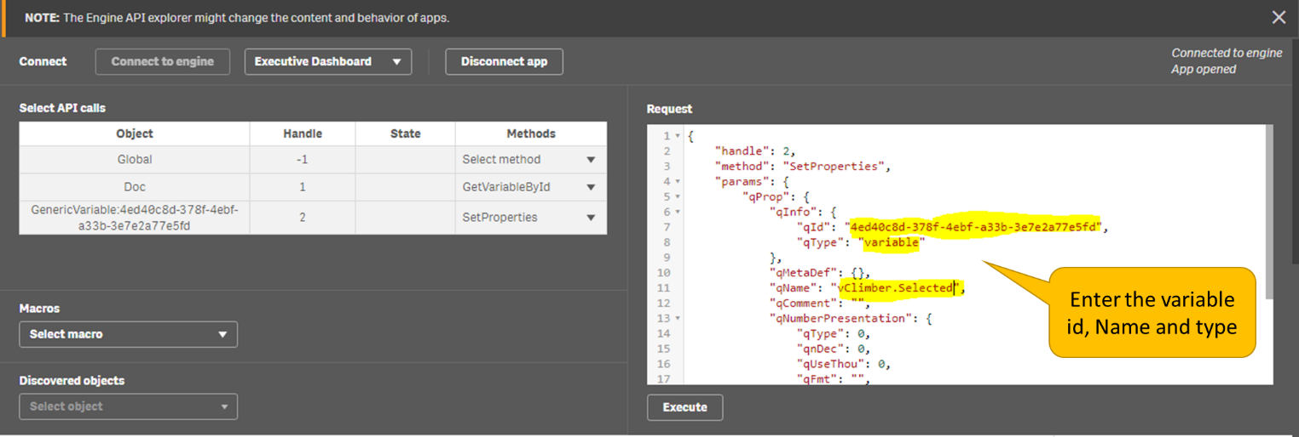

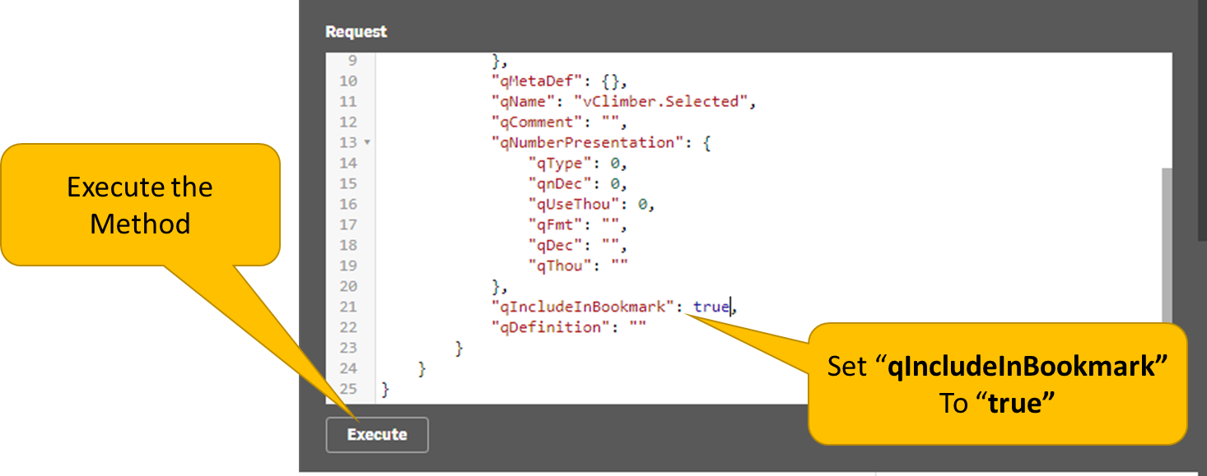

## Step 10:

Save the app once executed to persist the changes

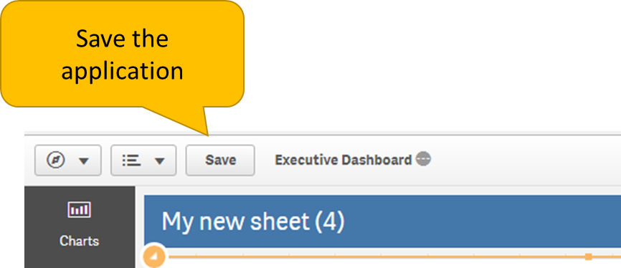

## Step 11:

Provide the variable name in climber extension property as shown below,

